**LEG Team**

**Users Manual – version 1**

**4/3/2019**

**Game background:**

Players will travel through time and space tunnels into another space world, so that need to avoid obstacles and collect energy for spaceship.

**Introduction:**

This is LEG Team; our game is Beat Runner. Our game is about player controls a character that avoid hitting the coming obstacle. The rule is very simple: there are many different obstacles, player should avoid hitting the stones or other shape of obstacles but collect coins. The length of the game depends on the background game music. Player need to collect the coins to get more higher score. There will be a score display board once end the game. There two different characters and one background map can be chosen now, LEG team are continuing set up more elements for that.

Menu:

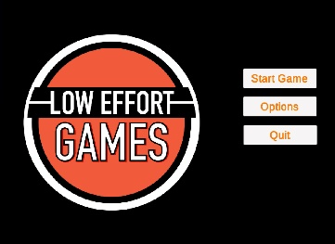 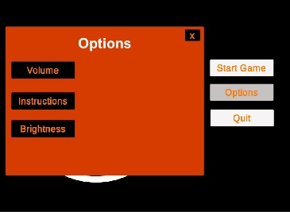

This the menu of the game. For our game, we have three buttons including: start game, options and quit. Player click the “Start Game” to open the game and “Quit” to end the game. For now, there are three different options can be chosen, which are volume, instruction and brightness. User can change the setting in the game and see the instruction. When click “Instruction”, there will be open a menu to show to controller which player will be use in the game.

**Character Controller:**

For now, there are four different movements available for character. This is available in “Instruction”.

“A” - Move to left

“B” - Move to right

“Space” - Jump

“S” – Slide

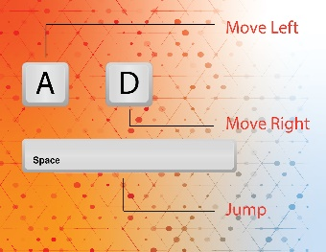

**Character selection:**

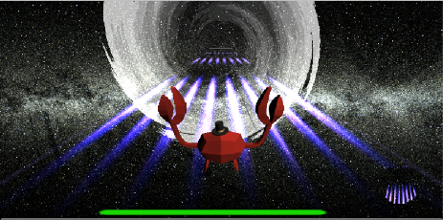 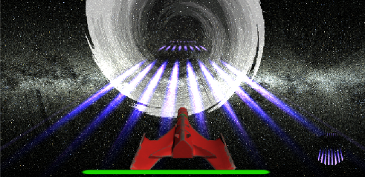

There are two character can be chosen in out game. One is for crab and another one is ship. Player can choose the character when start the game.

**Music background:**

The sound we use for background in this game is: Never Gonna Give You Up.mp3

The sound we use for hitting obstacle in this game is: CollisionSound.mp3

**Download:**

The game is visible to download in <https://github.com/loweffort/BeatRunner>